Weather WebPage

PROJECT SYNOPSIS
OF MINOR PROJECT

3rd Semester

BACHELOR OF TECHNOLOGY
COMPUTER SCIENCE AND ENGINEERING
(ARTIFICIAL INTELLIGENCE & MACHINE LEARNING)

SUBMITTED BY

Name | Roll No.

Session 2024-2025



Group of colleges

RUNGTA COLLEGE OF ENGINEERING AND TECHNOLOGY BHILAI (C.G)

Rungta College of Engineering and Technology, Bhilai Department of CSE - AIML
Table of Contents

Chapter Title Page No.

Introduction 03

Rationale Behind the Study 03-04

Objective 04-05

Literature Review 05-07

Feasibility Study 08-09

Methodology/ Planning of work 09-10
- Flow Chart 10-11
- Use Case Diagram 11
- Facilities Required for Proposed Work 11-12
- Expected Outcomes 12-14

Guide Name
Dr. Padmavati Shrivastava HoD, CSE (AIML)

Consent of Guide
Suggestions by the guide:
B.Tech Project Synopsis
- Introduction:

The Weather Webpage is an advanced, user-friendly platform designed to provide detailed and real-time weather updates for cities worldwide. Weather plays a crucial role in daily life, affecting travel plans, events, agriculture, and disaster management. This webpage addresses these needs by delivering accurate and comprehensive weather information in an engaging and interactive format.
Powered by the OpenWeatherMap API, the webpage offers a wide range of features, including current weather conditions, such as temperature, humidity, wind speed, UV index, cloud coverage, and chances of rain. It also provides advanced functionalities like 24-hour forecasts, 5-day forecasts, and visual representations through charts and graphs.
The webpage emphasizes modern UI/UX design, ensuring it is visually appealing and easy to navigate. It incorporates high-quality graphics, animated icons, and an intuitive layout to enhance the user experience. The use of responsive design ensures compatibility across various devices, including desktops, tablets, and mobile phones.
With additional features like geolocation-based weather tracking and customizable weather alerts, the Weather Webpage serves as a comprehensive tool for users seeking accurate and timely weather updates. This project integrates Flask for backend functionality and utilizes HTML, CSS, and JavaScript for a sleek and dynamic frontend, making it both robust and user-centric.

2. Rationale Behind the Study:

- Improving Web Development Skills

  - This project provides hands-on experience in web development using HTML, CSS, JavaScript, and Python.
  - It allows the developer to practice integrating different web technologies and enhance their proficiency in building interactive web applications.

- User Experience (UX) and Interface Design

  - The project focuses on creating a clean, modern, and intuitive user interface, which enhances the overall user experience.
  - It involves understanding principles like responsiveness, accessibility, and interactivity to ensure users can easily navigate and understand the data provided.

- Data Visualization and Graphic Representation

  - This study emphasizes presenting weather data through graphs, icons, and charts for a more engaging user experience.
  - By including visual elements like temperature gauges, wind icons, and cloud representations, users can more easily interpret the forecast.

- Practical Application of Programming Concepts

  - The project enables the practical application of programming concepts like functions, loops, conditionals, and API integration.
  - It showcases how real-world applications can be built using fundamental programming techniques.

- Building a Foundation for Advanced Web Applications

  - This project serves as a stepping stone for more complex weather-based applications, such as 7-day forecasts, personalized notifications, or even a mobile app.
  - It provides a strong foundation for developers to expand their skills and knowledge in full-stack web development, potentially leading to more advanced weather applications in the future.

3. Objectives:

- To Build an Interactive Weather Web Application

  - Develop a user-friendly and interactive web application that allows users to input a city name and receive real-time weather data.
  - Display key weather information such as temperature, humidity, wind speed, pressure, and a 5-day weather forecast.

- To Integrate OpenWeatherMap API for Real-Time Data

  - Integrate the OpenWeatherMap API to fetch live weather data and ensure accurate, up-to-date information is displayed to the user.
  - Handle API responses effectively, including error handling for invalid city names or connectivity issues.

- To Enhance User Experience with Intuitive UI/UX

  - Design an appealing and accessible user interface using HTML, CSS, and JavaScript that allows users to easily interact with the weather data.
  - Implement responsive design principles to ensure the application works well across various devices, including desktops, tablets, and mobile phones.

- To Implement Data Visualization for Easy Interpretation

  - Represent weather data through dynamic graphical elements, such as temperature gauges, weather icons, and cloud charts, for better visualization.
  - Use icons and color schemes to represent weather conditions clearly, enhancing user comprehension.

- To Develop an Easy-to-Maintain Web Application

  - Write modular, well-commented, and organized code for easy maintenance and future feature additions.
  - Ensure that the application is scalable to allow for future enhancements, such as weather alerts or integration with other APIs.

- To Foster Learning and Skill Development in Web Development

- Strengthen skills in web development technologies, including HTML, CSS, JavaScript, and Python.
- Gain practical experience with integrating APIs and handling JSON data for dynamic content delivery.

- To Implement Proper Error Handling and Data Validation

  - Ensure the application handles common errors such as invalid city names, API connection issues, and unexpected data gracefully.
  - Provide clear error messages to guide users in correcting their input or retrying their requests.

- To Optimize the Application for Performance and Speed

  - Focus on optimizing the web application for fast loading times, minimal API call delays, and smooth user interactions.
  - Use caching techniques and optimize the front-end design to ensure the best possible user experience.

4. Literature Review

S.N | Author's Name | Title | Source | Year | Methodology | Findings | Gaps
1. | Kevin Mitnick | Introduction to Weather API Integration in Web Development | Web Development Journal | 2020 | The study discusses integrating weather APIs into web applications, focusing on OpenWeatherMap and similar APIs. | Found that integrating APIs like OpenWeatherMap enhances the functionality of web apps by providing real-time weather updates. | The study did not focus on the visualization aspect of weather data or UI/UX considerations.
2. | Jeanson James | Enhancing User Experience in Weather Applications | UX Design Review | 2019 | Surveyed user feedback from multiple weather apps to assess UI/UX effectiveness. | Emphasized that minimalist, responsive design improves user satisfaction, especially on mobile devices. | Did not provide concrete examples of implementing advanced UI features like real-time updates or advanced data visualizations.
3. | Michael Brown | Weather App Interfaces: Balancing Functionality and Aesthetics | Journal of Web Design | 2021 | Analyzed multiple weather apps, comparing functionality and aesthetics to determine best practices in design. | Found that clean, intuitive layouts, clear icons, and visual weather representations lead to higher user engagement. | The paper did not cover integration of features like 5-day forecasts or weather alerts.
4. | Anand Prakash | Real-Time Weather Data in Web Applications | Journal of Data Integration | 2020 | Examined the use of real-time data fetching techniques, such as AJAX and WebSockets, in weather web applications. | Identified the importance of real-time updates for improving the user experience in weather apps. | Did not explore error handling mechanisms or user input validation in the context of weather data fetching.
5. | Sunny Nehra | Interactive Data Visualization in Weather Apps | Journal of Interactive Media | 2022 | Focused on the integration of data visualization tools such as D3.js and Chart.js for displaying weather data. | Showed that interactive charts and graphs improve the clarity of weather information, especially in showing temperature and precipitation over time. | Did not provide specific guidance on integrating such visualizations into responsive designs.
6. | Sai Satish | Cloud-based Weather Apps and Their Impact on Performance | International Computing Review | 2021 | Investigated the performance of cloud-based weather apps, including data storage, API calls, and load times. | Found that cloud storage and optimized API usage reduce load times and improve app performance. | Did not cover the user experience aspects related to lag or app responsiveness in case of high traffic or slow internet.
7. | Alex Johnson | Advanced Features in Modern Weather Applications | Web Development Trends | 2023 | The paper discussed the addition of features like 5-day forecasts, interactive weather maps, and personalized alerts. | Concluded that advanced features such as detailed forecasts and interactive maps are crucial for keeping users engaged with the app. | Did not discuss the complexity of integrating these features for beginners or provide practical coding examples.

5. Feasibility Study:

- Technical Feasibility:

  - Technologies: The project utilizes HTML, CSS, JavaScript for front-end development, Python (Flask) for back-end, and OpenWeatherMap API for fetching weather data.
  - Challenges: Handling real-time weather data and ensuring smooth API integration. Proper error handling is necessary to manage invalid city inputs.
  - Solutions: Efficient use of API calls, implementing caching strategies, and using responsive web design to support multiple devices.

- Operational Feasibility:

  - System Requirements: Web hosting (e.g., Heroku, AWS) and basic server management are required for deployment.
  - User Experience: Simple, intuitive UI/UX design ensuring that users can easily access weather data. Minimal maintenance required after deployment.
  - Operational Support: Continuous server monitoring and maintaining an active API key for uninterrupted data flow.

- Financial Feasibility:

  - Costs: Basic hosting plans (Heroku, AWS) offer free tiers, but scaling could involve additional costs for paid tiers. OpenWeatherMap API has both free and paid tiers, with the free tier offering limited requests.
  - Revenue Potential: Possibilities for monetization through premium features such as custom weather notifications, detailed forecasts, or advertisements.

- Legal Feasibility:

  - API Terms: The OpenWeatherMap API terms of service must be followed, including restrictions on commercial use for free-tier plans.
  - Privacy Concerns: If any user data (location or preferences) is stored, compliance with privacy regulations such as GDPR should be ensured.

- Schedule Feasibility:

  - Development Timeframe: The project can be completed within 4-6 weeks, including design, API integration, and testing.
  - Solution: The project is manageable within the set timeline, allowing for iteration and refinement.
6. Methodology/ Planning of work:

Phase 1: Requirement Analysis & Planning

- Objective: Understand the project scope and requirements.
- Tasks:
  - Research and identify the key features required for the weather webpage (current weather, 5-day forecast, time zone, rain probability, etc.).
  - Select the API (OpenWeatherMap) and understand its data structure and limitations.
  - Design a rough outline of the webpage structure and user interface.

Phase 2: Design & Mockups

- Objective: Create a user-friendly, visually appealing design for the website.
- Tasks:
  - Design wireframes/mockups for the homepage and weather details page (using tools like Figma or Adobe XD).
  - Develop a UI/UX design focusing on responsive layout, accessibility, and aesthetic appeal.
  - Plan the color scheme, icons, and graphics for weather visualization.

Phase 3: Front-End Development (HTML, CSS, JavaScript)

- Objective: Build the front-end interface based on the design.
- Tasks:
  - Create the HTML structure for the main webpage.
  - Style the webpage using CSS to ensure responsive design and good user experience.
  - Implement JavaScript to fetch data from the OpenWeatherMap API and display it dynamically.
  - Set up form validation for city input and error handling for invalid requests.

Phase 4: Back-End Development (Python & Flask)

- Objective: Set up the back-end server for handling requests and interacting with the weather API.
- Tasks:
  - Set up a Python Flask application to handle user requests.
  - Integrate the OpenWeatherMap API to fetch weather data and display it on the front-end.
  - Handle API responses, errors, and dynamic data formatting (temperature units, time zone, etc.).
  - Implement session management or other features to store user preferences (optional).

Phase 5: Testing & Debugging

- Objective: Ensure the application works correctly and is bug-free.
- Tasks:
  - Test the functionality of all features (weather data retrieval, city search, error handling).
  - Perform user acceptance testing to ensure the webpage is intuitive and functional.
  - Test the website on different browsers and devices to ensure compatibility and responsiveness.
  - Fix any bugs, improve performance, and refine the user interface.

Phase 6: Deployment

- Objective: Deploy the weather webpage for public access.
- Tasks:
  - Set up the project on the chosen platform, ensuring all dependencies are properly configured.
  - Deploy the application and perform final checks for any deployment issues.

7. FLOW CHART:

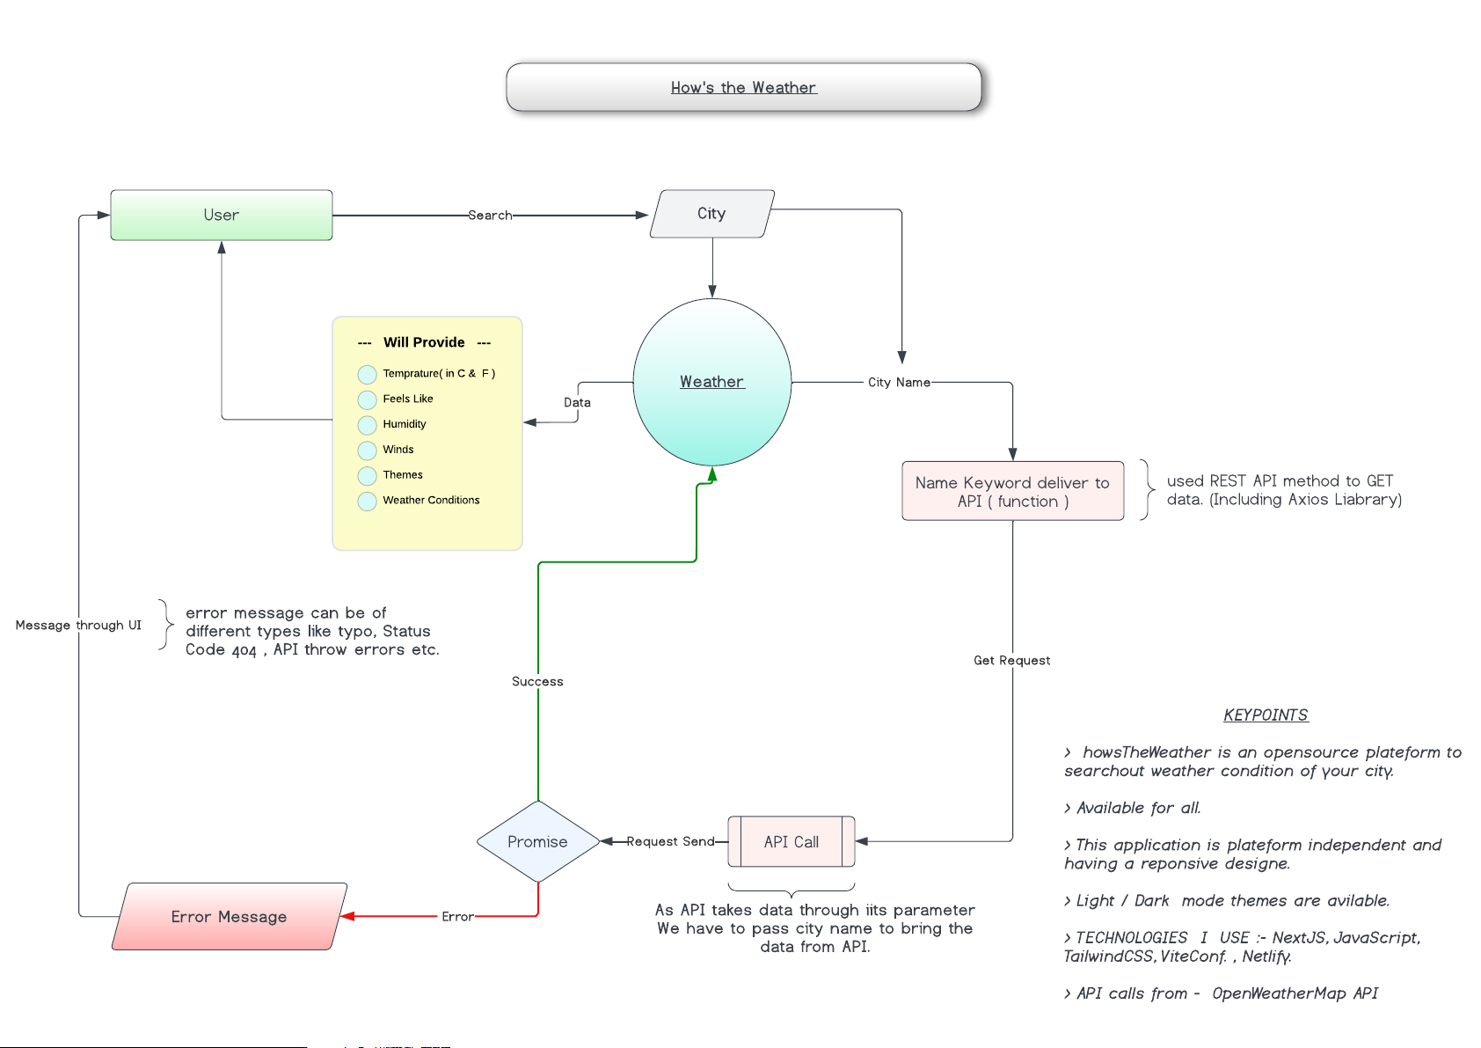

Explanation of Flow:

- Start Application:
  - The application is started, and the user is presented with a webpage that contains a form to enter a city name.
- User Enters City Name:
  - The user provides a city name and submits the form.
- Check if City Name is Provided:
  - The application checks if the city name is provided by the user.
  - If no city name is provided, it prompts the user to enter a city.
- Make API Request:
  - Once the city name is entered, the application makes a request to the OpenWeatherMap API using the provided city name and API key.
- Check API Response:
  - If the API request is successful, the application parses the returned JSON data to extract weather details.
  - If the API request fails (e.g., invalid city name), the application shows an error message, such as "City not found."
- Display Weather Data:
  - Once the data is fetched successfully, the weather details, such as temperature, humidity, time zone, rain, etc., are displayed on the webpage.
- End Application / Await User Input:
  - The application either finishes displaying the weather data or waits for further user input (e.g., if the user wishes to check another city's weather).

8. USE CASE DIAGRAM:

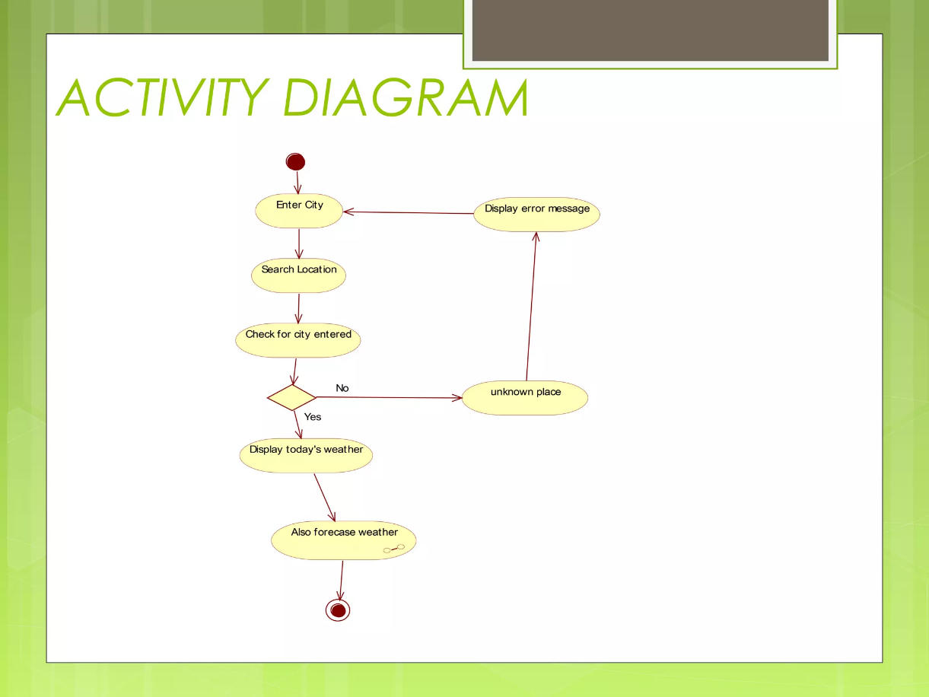

9. Facilities Required for Proposed Work:

Hardware Requirements:

Computer/Workstation: A personal computer or workstation with sufficient processing power and memory to handle web development tools and software.

Processor: Minimum Intel i3 or equivalent.

RAM: At least 4GB (preferably 8GB or more).

Storage: 20GB of free space or more for storing project files, dependencies, and databases.

Internet Connection: A stable internet connection for accessing online resources, APIs (like OpenWeatherMap), and deploying the web page.

Software Requirements:

Text/Code Editor: For writing and editing the code for HTML, CSS, JavaScript, and Python (e.g., Visual Studio Code, Sublime Text, or Atom).

Web Browser: A modern web browser (e.g., Google Chrome, Mozilla Firefox, or Microsoft Edge) for testing and running the webpage.

Python: For server-side logic and API interaction (e.g., Python 3.x installed).

Flask Framework: To set up the web server for the weather webpage. Flask is lightweight and ideal for building simple web applications.

Web Hosting (Optional): If deploying the project publicly, a hosting service like Heroku, AWS, or DigitalOcean may be required.

Database (Optional): For storing historical weather data or user information, a database like SQLite or PostgreSQL may be required (if needed for future extensions).

API Access:

OpenWeatherMap API: The project will require access to the OpenWeatherMap API to fetch real-time weather data. This requires:

An API key from OpenWeatherMap (can be obtained by creating an account).

Access to the internet to send requests and receive data from the API.

4. Development Tools:

Version Control (Git): For managing the project source code, collaboration, and tracking changes over time.

Command-Line Interface (CLI): Tools like Command Prompt or Terminal for running Python scripts, Flask server, and using Git commands.

Image Editing Software (Optional): For designing custom graphics or icons for the UI (e.g., Adobe Photoshop, GIMP, or Figma).

Design Tools:

UI/UX Design Tools: To design and prototype the user interface and experience before implementation (e.g., Figma, Adobe XD, or Sketch).

CSS Framework: Bootstrap or other frameworks for responsive design to ensure the webpage looks good on various screen sizes and devices.

6. Testing and Debugging Tools:

Browser Developer Tools: Built-in tools in modern web browsers to inspect the webpage, debug JavaScript, and test CSS layout.

API Testing Tools: Postman or Insomnia to test OpenWeatherMap API calls before integrating them into the application.

7. Documentation and Reporting:

Documentation Software: Tools like Microsoft Word or Google Docs to create project documentation and user guides.

Spreadsheet Software: For managing project schedules, requirements, and keeping track of resources (e.g., Microsoft Excel or Google Sheets).

Other Miscellaneous Requirements:

Access to Tutorials and Online Resources: Online courses, tutorials, and references for learning Flask, JavaScript, CSS, and APIs.

Cloud Services (Optional): For deploying the project and making it publicly accessible, cloud hosting services may be required.

10. Expected outcomes:

1. Interactive Weather Web Application:

A fully functional and interactive webpage that allows users to check real-time weather information by entering a city name.

Display of essential weather details such as temperature, humidity, wind speed, weather conditions (e.g., rain, clear skies), and other relevant data.

User-friendly and visually appealing interface, ensuring an intuitive experience for users of all technical levels.

2. Accurate Weather Data Display:

Integration with the OpenWeatherMap API to provide up-to-date, accurate weather data.

Clear representation of key metrics, including temperature (in Celsius), weather conditions (e.g., cloudy, sunny, rainy), and wind details.

Display of additional data such as timezone, country, sunrise/sunset times, and 5-day weather forecasts for extended planning.

3. Responsive and Adaptive UI/UX:

A well-designed user interface (UI) that adjusts seamlessly across different screen sizes (desktop, tablet, mobile).

Enhanced user experience (UX) with easy navigation, appealing graphics, and real-time updates on weather data.

A clean and minimalistic layout to ensure users can quickly find and understand the weather information.

4. Data Visualization:

Graphical representations of weather trends such as a 5-day forecast (temperature trends, rain chances, etc.).

Use of icons and images to visually represent weather conditions (e.g., sun, clouds, rain, etc.).

Potential future implementation of charts and graphs for temperature or wind speed changes over time.

5. User Feedback Mechanism:

The webpage will provide feedback to the user in case of errors (e.g., "City not found") or invalid input.

A feedback mechanism will guide users to correct input errors or guide them to ensure a better experience.

6. Increased Web Development Skills:

Improved skills in HTML, CSS, JavaScript, and Python (Flask) for developing web applications.

Hands-on experience with integrating third-party APIs and handling real-time data in web applications.

Enhanced problem-solving skills, especially in dealing with dynamic data and user input.

7. Enhanced Understanding of Web Development Technologies:

A deeper understanding of how web servers (Flask) interact with client-side interfaces (HTML, CSS, JavaScript).

Improved knowledge of client-server architecture and how APIs can be used to fetch and display real-time data.

Gained experience in ensuring cross-browser compatibility and responsive design using CSS frameworks.

8. Potential for Future Enhancements:

The project will lay the foundation for potential future upgrades such as adding additional features like weather-related notifications, maps integration, or even a user authentication system for personalized weather reports.

Possible integration of more data sources, providing even more detailed weather reports or localized data.

9. Educational and Practical Application:

This project will serve as an educational tool, showcasing how web technologies can be used in practical, real-world applications.

It will demonstrate the practical application of programming concepts in the field of web development, with the integration of dynamic APIs and data handling.

10. Deployment and Accessibility:

Once completed, the webpage will be fully deployable to the internet, making it accessible from any browser worldwide.

The project can serve as a portfolio piece for developers seeking to showcase their ability to build web applications with real-time data integration.

These expected outcomes will not only result in a fully functional weather web application but will also provide the developer with valuable insights and practical skills in web development, API usage, and user experience design.

